Day20 - Task 08 - AWS EC2

1. Launch one EC2 using Amazon Linux 2 image and add a script in user data to install Apache.
Objective
Launch an Amazon Linux 2 EC2 instance and automatically install the Apache web server during instance initialization using a User Data script.
Steps Performed
- Open the AWS Management Console.
- Navigate to EC2 → Launch Instance.
- Enter the instance name (e.g., AmazonLinux-Apache).
- Select Amazon Linux 2 AMI.
- Choose t3.micro.
- Create or select an existing key pair.
- Allow inbound HTTP (80) and SSH (22).

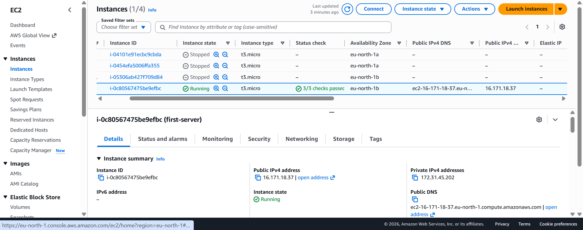
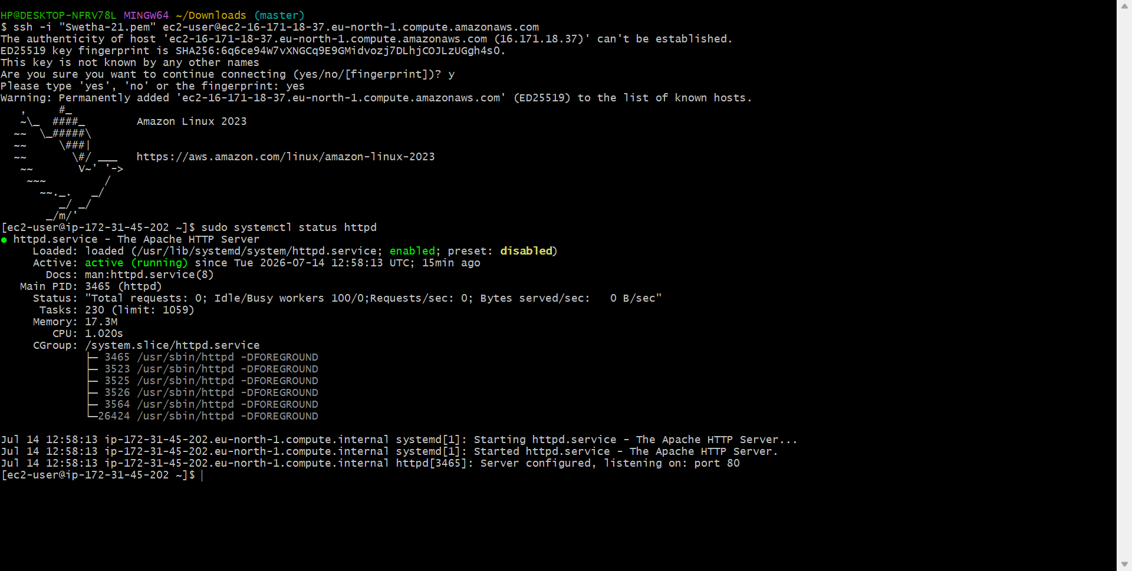
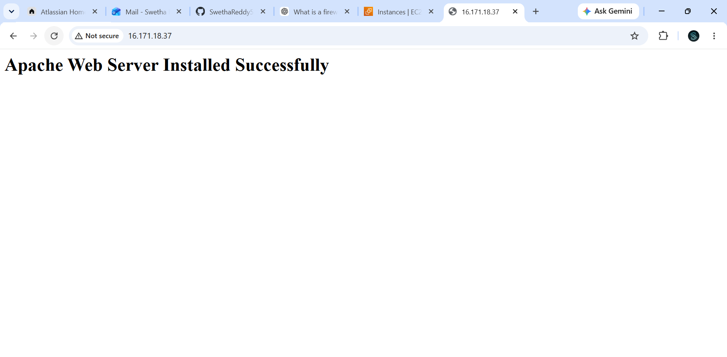
2. Launch one EC2 using Ubuntu image and add a script in user data to install Nginx.
Objective
Launch an Ubuntu EC2 instance and automatically install the Nginx web server.
Command | Purpose

apt update -y | Updates the Ubuntu package repository.

apt install nginx -y | Installs the Nginx web server.

systemctl start nginx | Starts the Nginx service.

systemctl enable nginx | Enables Nginx to start automatically after reboot.

echo ... > /var/www/html/index.html | Replaces the default web page with a custom page.

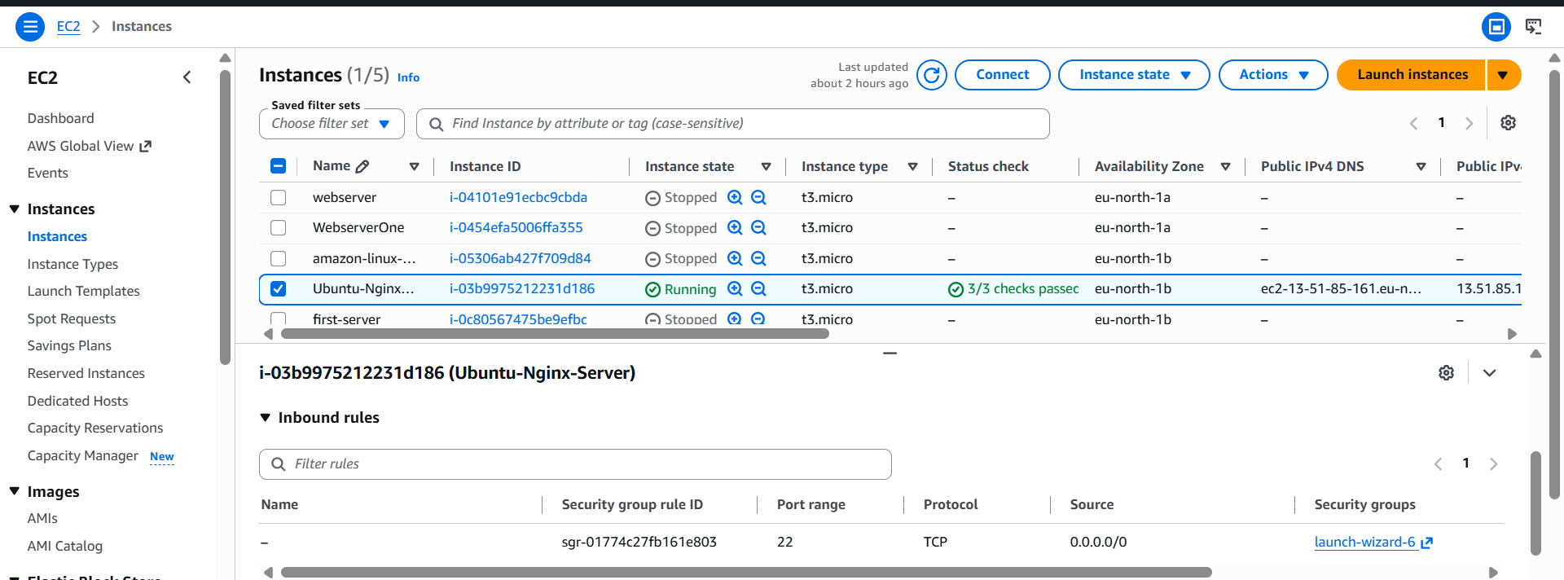
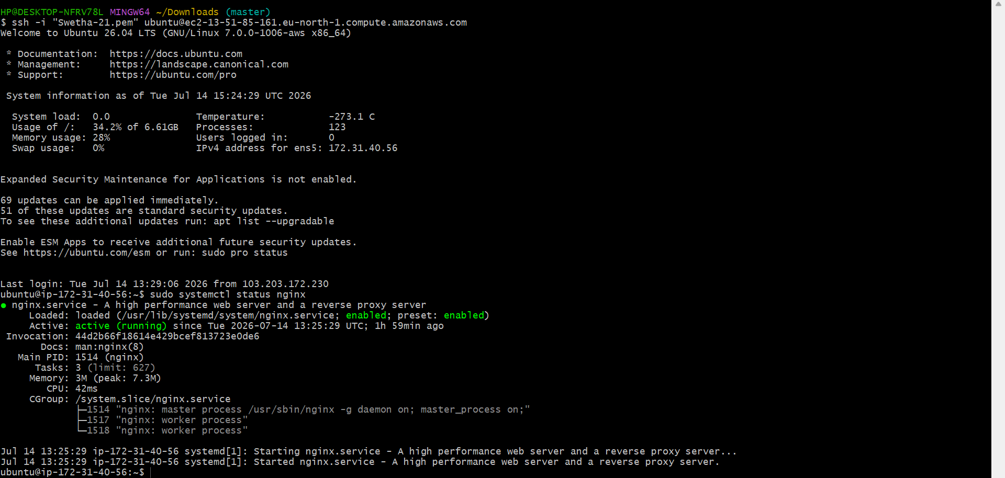
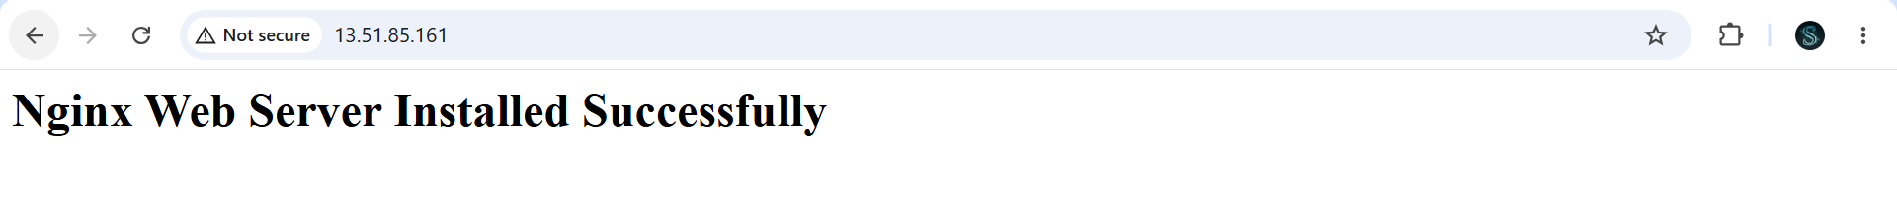
3. Launch one Windows server and install Tomcat on Windows.
Objective
Launch a Windows EC2 instance and install Apache Tomcat to host Java web applications.
AWS Steps
- Launch Windows Server 2022 EC2.
- Wait until the instance is running.
- Connect using Remote Desktop (RDP).
- Download and install Java JDK.
- Download Apache Tomcat ZIP.
- Extract Tomcat to C:\Tomcat.
- Configure JAVA_HOME.
- Start Tomcat.

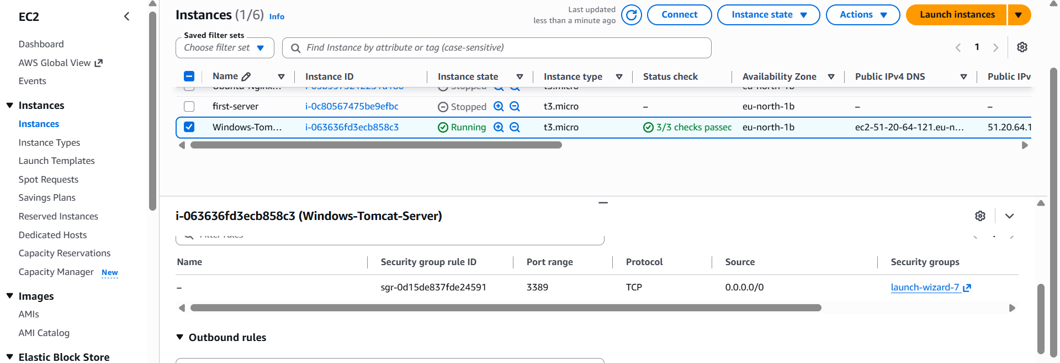

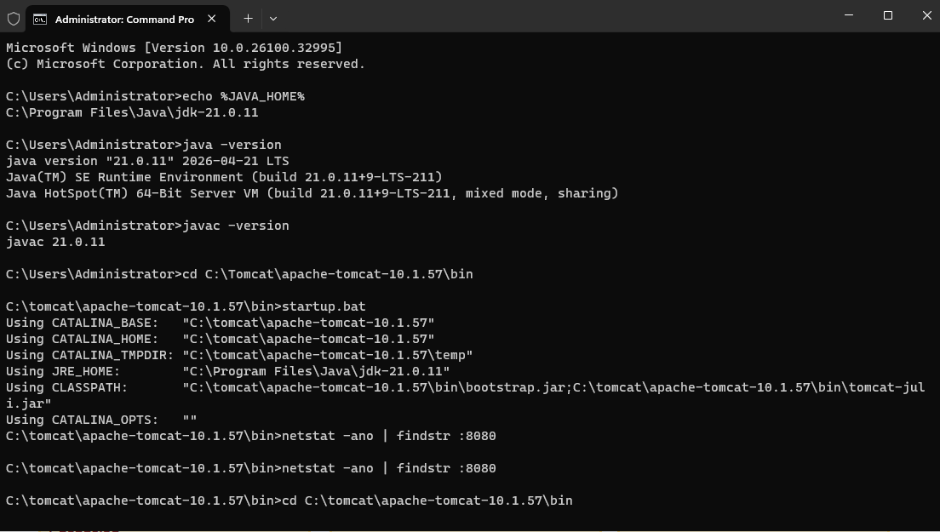
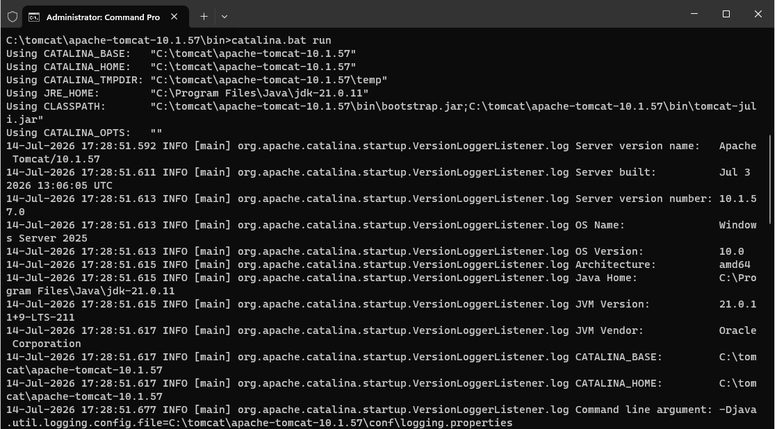
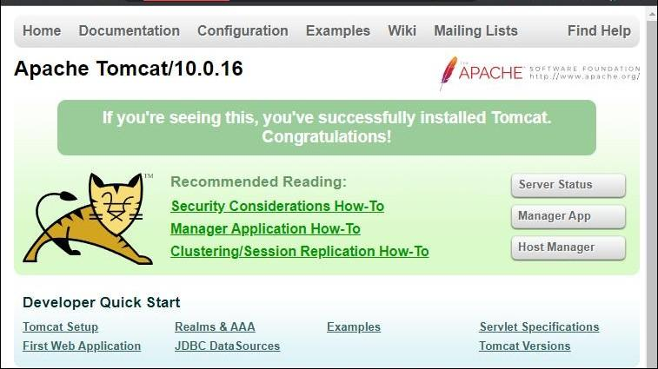

4. Take a snapshot of the instance created in Task 1.
Objective
Create a backup of the EC2 root volume.
Steps
- EC2 Console.
- Select the Amazon Linux instance.
- Open the Storage tab.
- Click the Volume ID.
- Select Actions → Create Snapshot.
- Provide a description.
- Create Snapshot.
Explanation
A snapshot is a point-in-time backup of an EBS volume stored in Amazon S3.

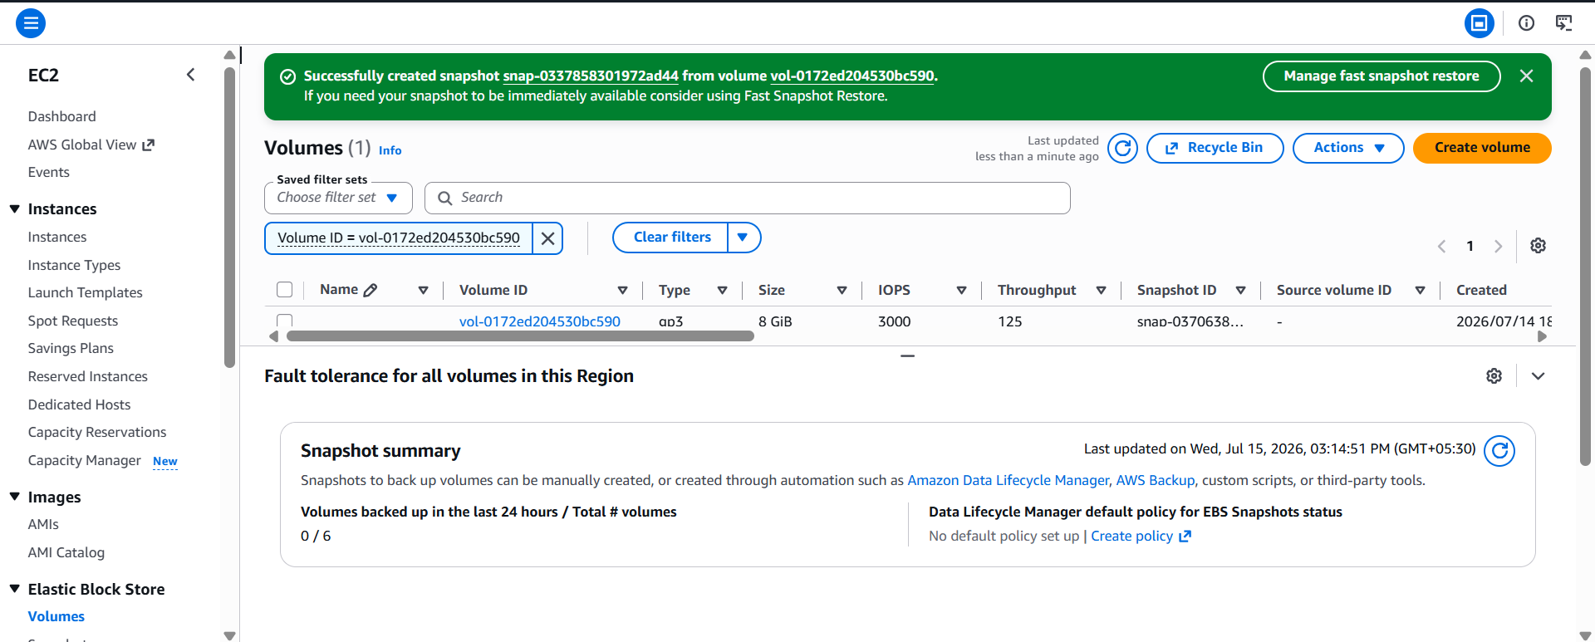
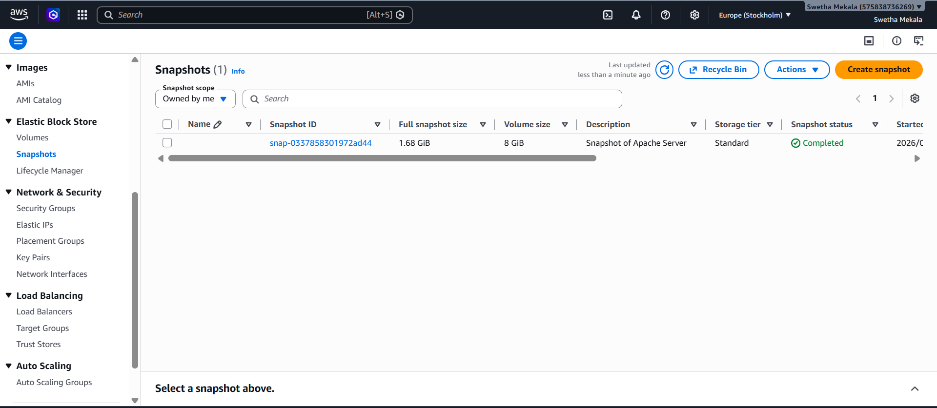
5. Assign passwordless authentication for the EC2
Objective
Allow SSH login without entering a password.
Generate SSH key:
ssh-keygen
View generated keys:
ls ~/.ssh
Copy public key to another EC2
ssh-copy-id ec2-user@<Target-IP>
Verify Passwordless Login
ssh ec2-user@<Target-IP>

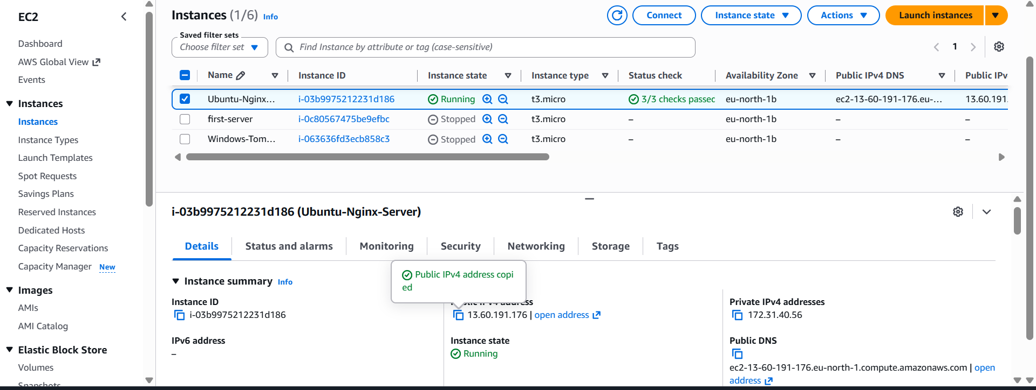

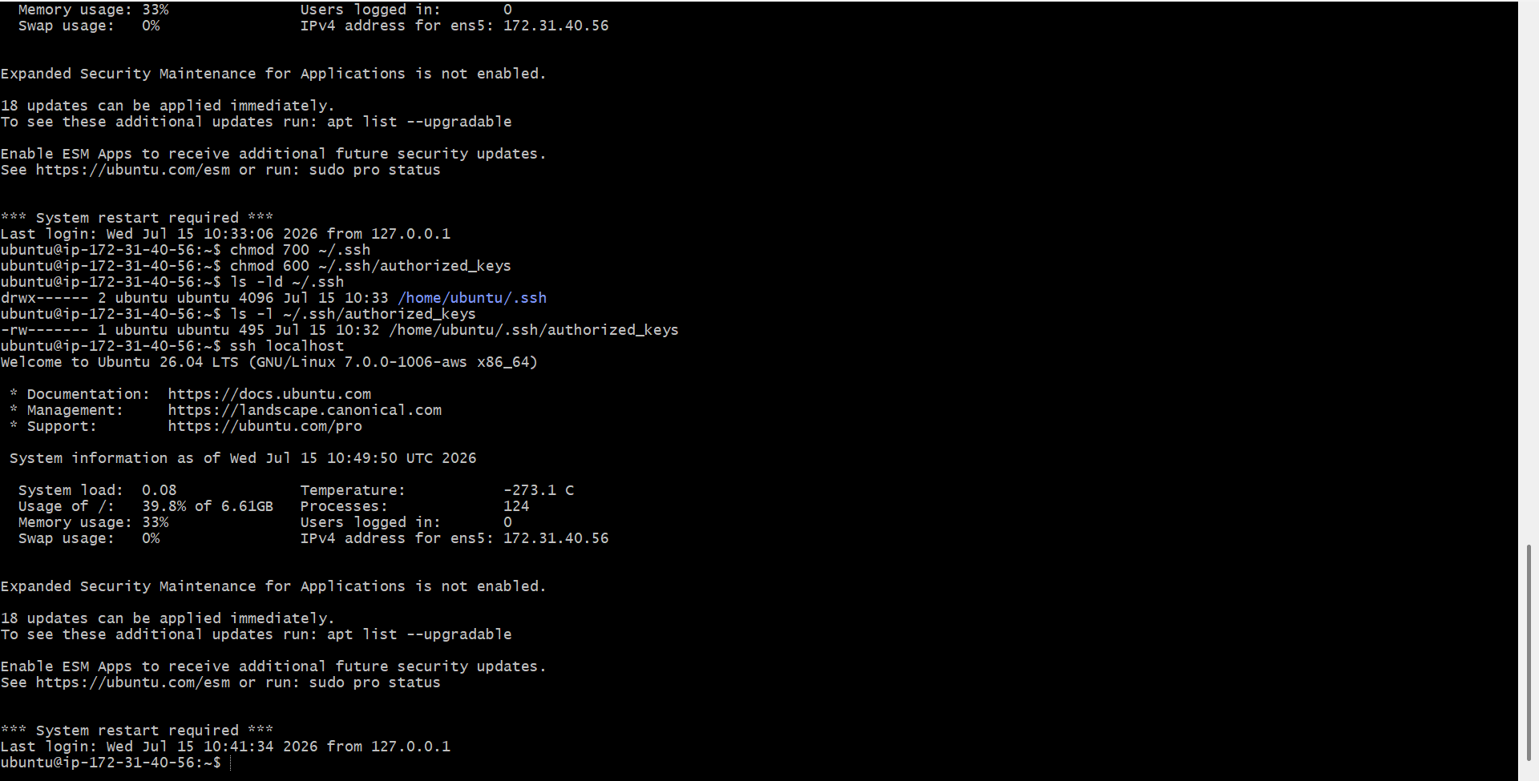
6. Launch any EC2 using the spot purchasing option.
Objective
Launch a low-cost Spot Instance.
Steps
- Launch Instance.
- Choose AMI.
- Select Instance Type.
- Expand Advanced Options.
- Choose
Request Spot Instances
- Launch.

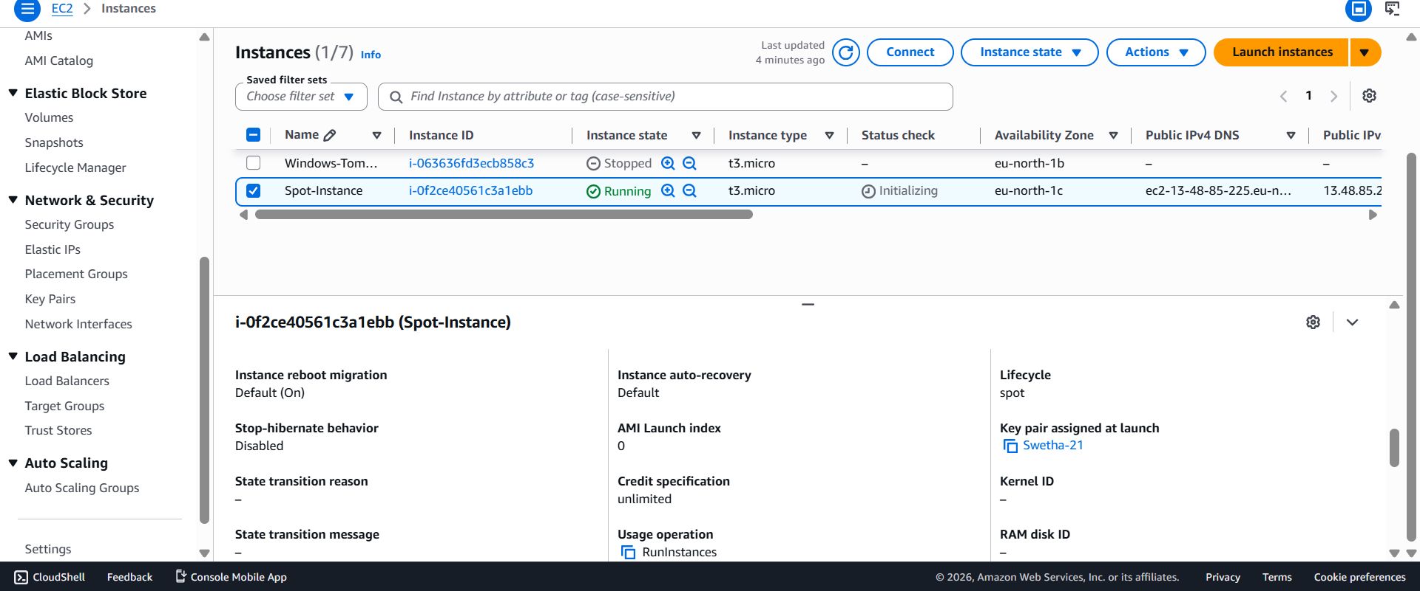
7. Enable termination policy on the EC2 created in Task 2.
Objective
Prevent accidental deletion of the Ubuntu EC2 instance.
Steps
EC2
→ Select Instance
→ Actions
→ Instance Settings
→ Change Termination Protection
Select
Enable

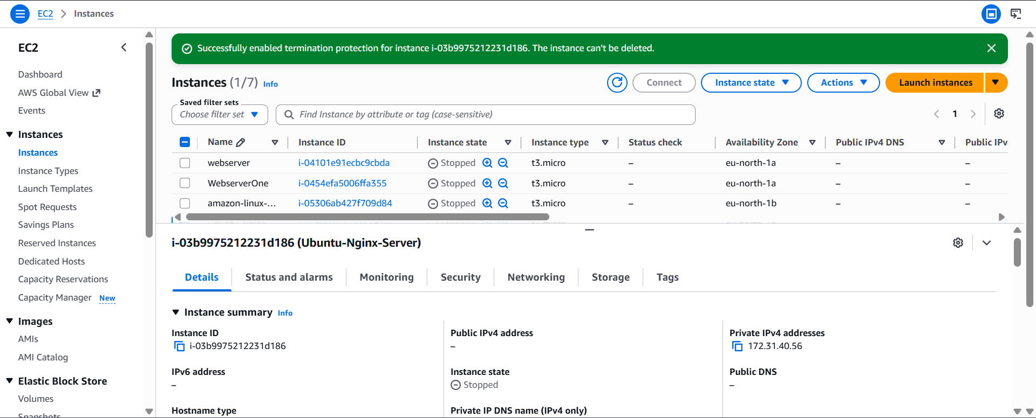
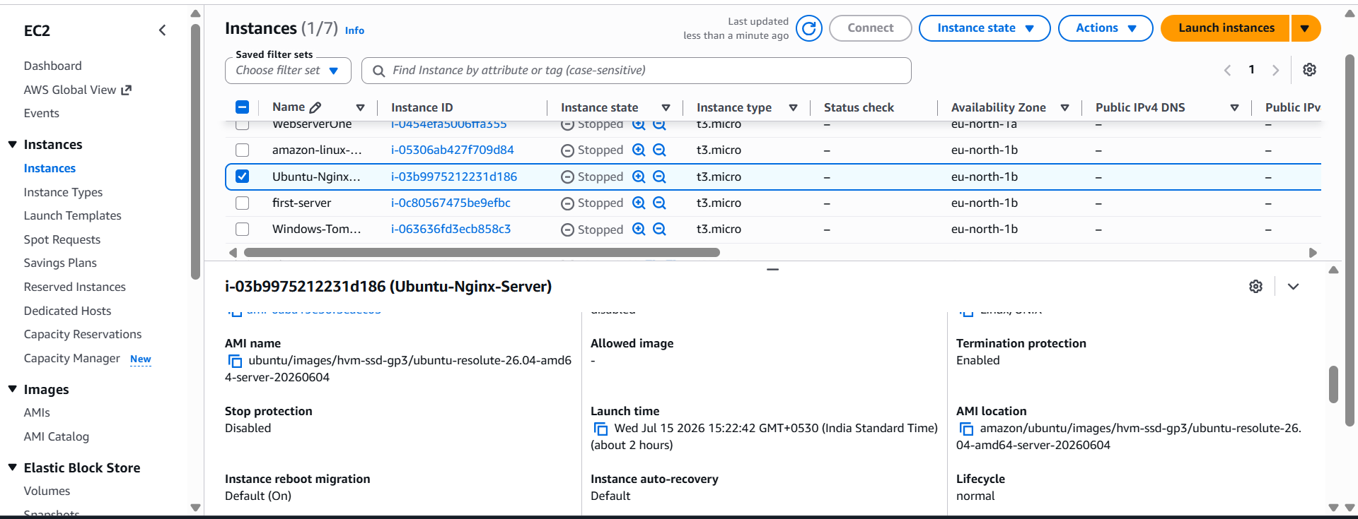
8. Launch one EC2 using AWS CLI.
Objective
Launch an EC2 instance from the command line.
Verify AWS CLI Identity
aws sts get-caller-identity
Purpose:
Checks which AWS identity (IAM role or user) the AWS CLI is currently using.

